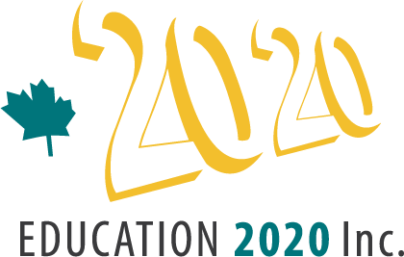 Education 20/20 Inc.
101 Kent St., PO Box 624/rue Kent, BP 624
Charlottetown, PEI C1A 1M0 Canada
Tel: 902-892-2060
Email: pei@education2020.ca
_____________________________________________________________________________________
Jun1 11, 2016
Mr. Wayne Hambly, President
Hambly’s Home Furnishings
86 Kensington Road
Charlottetown PE
C1A 5J4

Dear Wayne:
I enjoyed our recent conversation, although it was all too short.
To recap about education; for education to improve, we need to convert an inward-looking, bureaucratic delivery system to an outward looking, nimble organization focused on helping youngsters develop into responsible citizens. Are we making progress? I think so. The Premier’s commitment to consultation is a step in the right direction – but it is not enough. The enclosed Call for Action lists seven other items that we believe should be on the education agenda.
To date, Education 20/20 Inc. has focused on gathering information, a monthly bilingual newsletter, public workshops and presentations, a school awards program, and the inevitable meetings. While these will continue, we plan to step up our campaign for change, to be more public in our efforts, to lobby for other delivery and assessment models and to work on narrowing the gap between graduation requirements and what students need in their various life roles. We also plan to switch the focus of our Education Award from schools to community led education initiatives.
We all have many requests for financial support and there are many worthy causes. If you have an interest in any of our activities, I’d be delighted to provide further information. If that leads to financial support, we will be appreciative but, if not, I still look forward to future conversations.
Sincerely

Don Glendenning
President

